7. SIGNAL RECONSTRUCTION AND SPECTRAL ANALYSIS
Experiment 7.1
Fourier Series of Half-Wave Rectifier Output
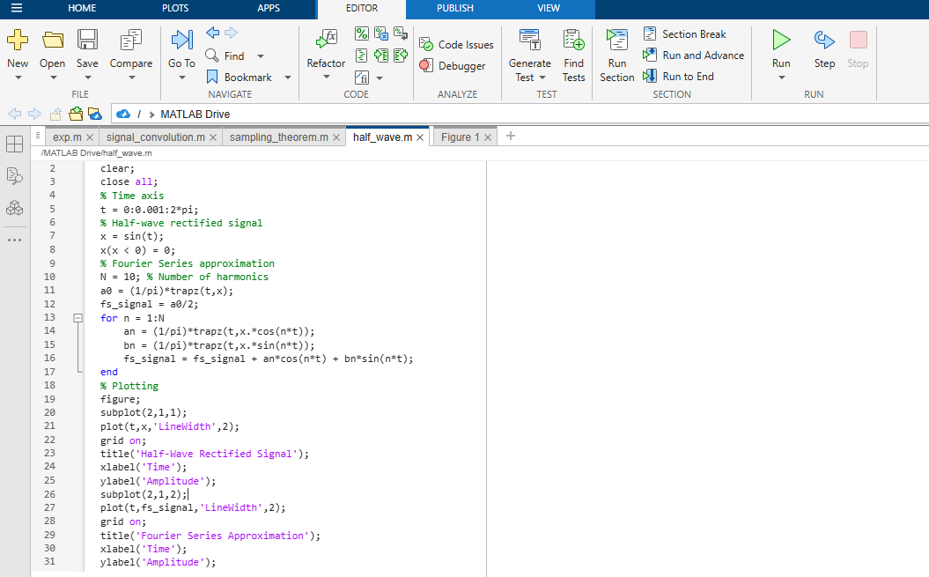
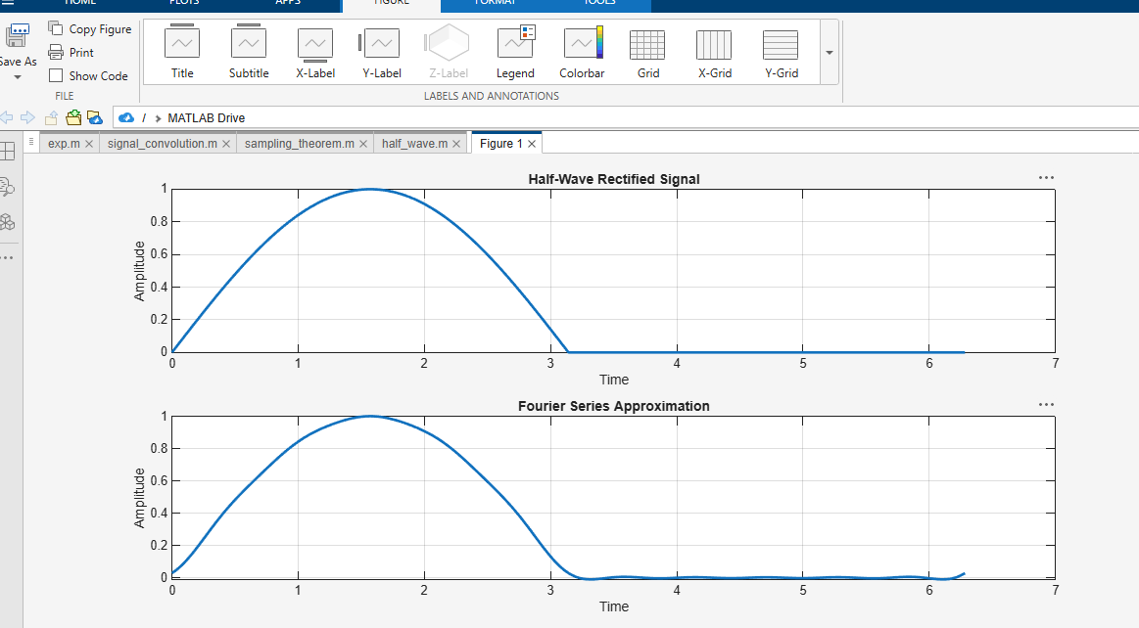

Experiment 7.2
Fourier Transform of a Rectangular Waveform
